Janis Innis
Topic Five
Comparison/Contrast Essay
13 Oct. 2013

A Thirst for Water
The National Administration for Space and Aeronautics (NASA) is the premier space exploration government agency on Earth. Not only are they the only entity to land men on the moon, but also are also possibly in line to be the first to place men on Mars in the near future. One might ask, “What fuels these space quests by NASA and ultimately the American people?” A simplified answer might be the search for water and in doing so, perhaps to help explain the mystery of life in the universe, as we know it. According to astrophysicists and many other fields of scientists, water holds a key, among others, to explain the origins of life (Tyson).
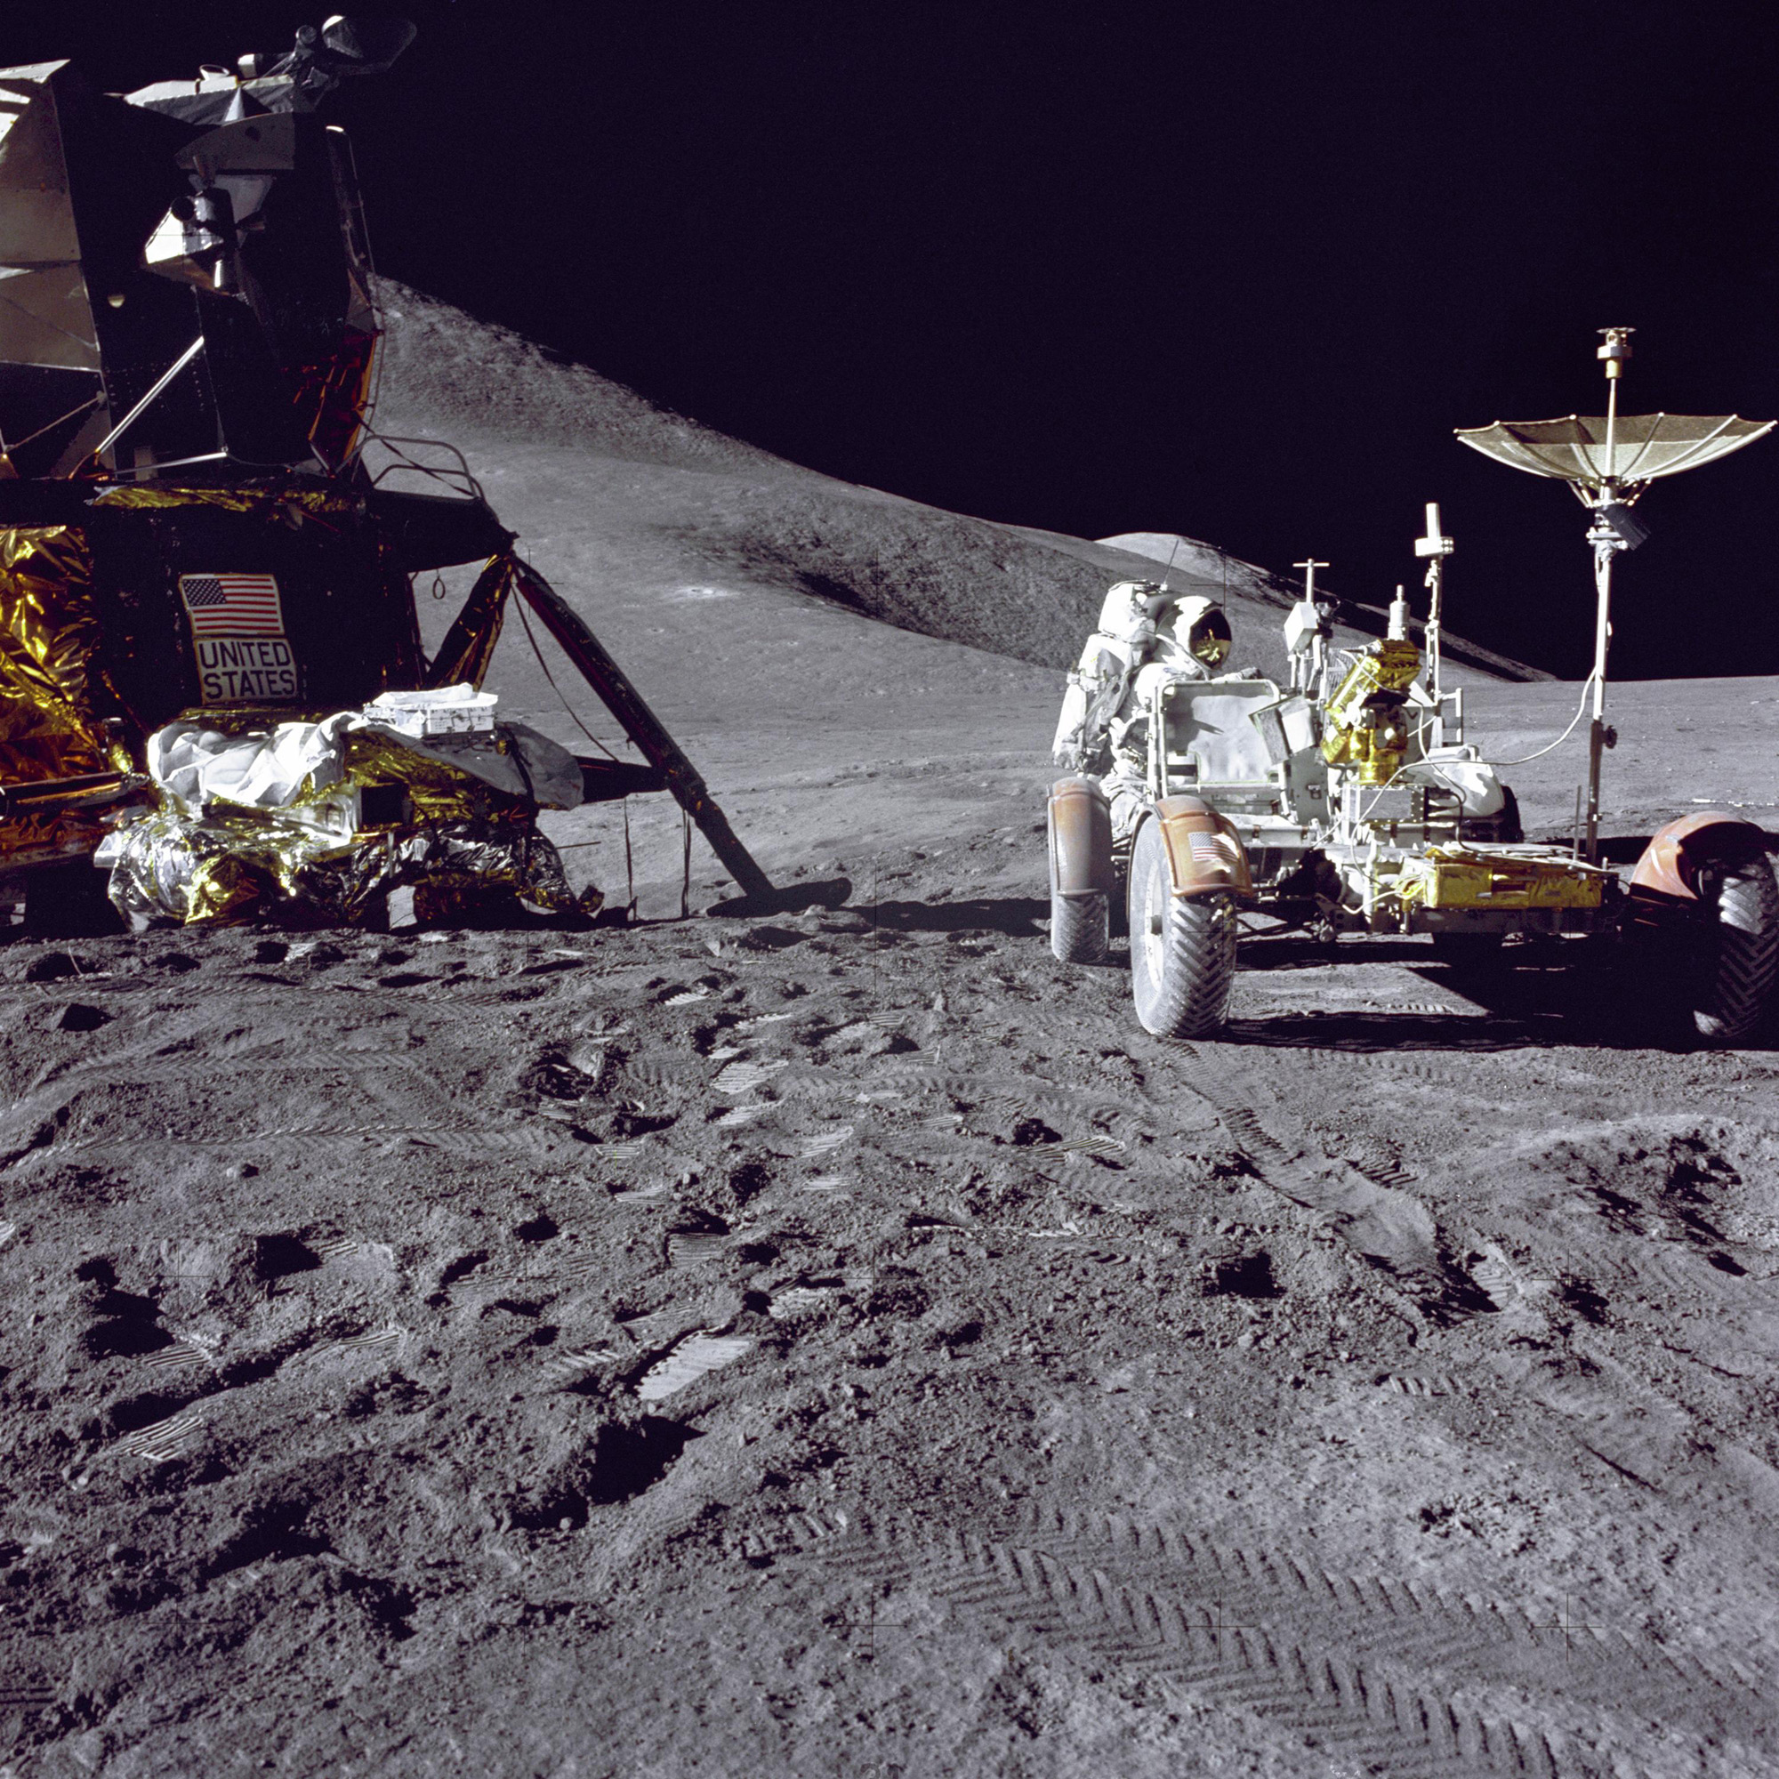
(NASA’s)
One of the goals for the Apollo missions was to find the evidence of water on the moon. “Early isotopic studies also revealed similarities between the water in some lunar soils and on Earth” (McKee). These studies indicate the presence of water as was suspected.
Soil collected during all Apollo landings contained traces of water. And material scooped up by Apollo 16 had signs of methane and hydrogen cyanide, compounds found in comets - a possible source of the stuff. The ugly spectre of contamination was raised because none of the 12 "rock boxes" carrying the Apollo samples kept their vacuum during transit, with about half returning to the Earth's atmospheric pressure. Early isotopic studies also revealed similarities between the water in some lunar soils and on Earth (McKee).
In the same fashion, a key goal for the Mars mission is to search for traces of past water on the red planet. When asked, “What do you think are the odds of finding evidence of life on Mars?” the noted astrophysicist Dr. Neil deGrasse Tyson answered, “High — certainly higher than 50 percent. And by life, I refer to fossil life, not current life; and simple life, bacteria or microbes. Water is the key” (Tyson).
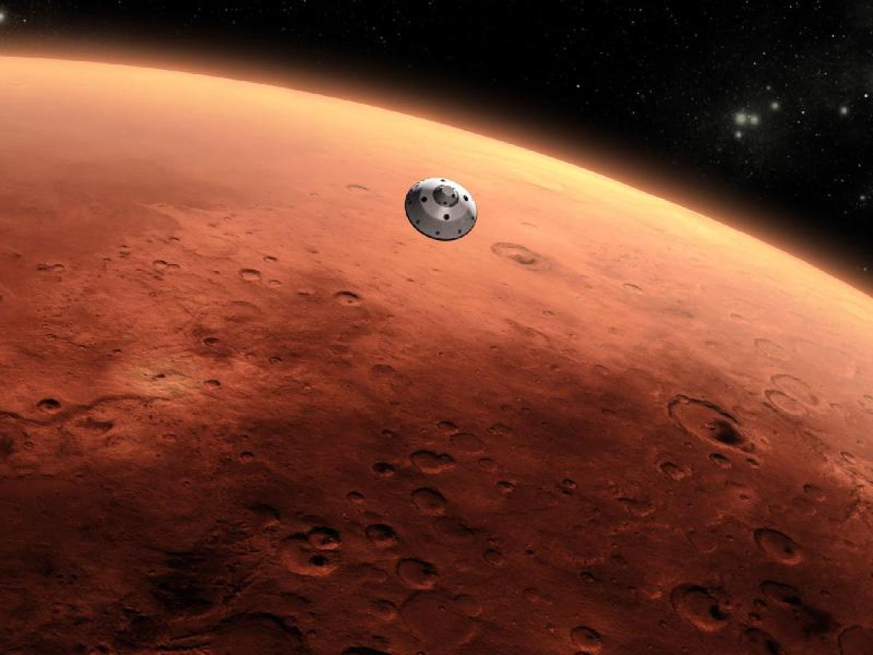
(Cooper-White)
One loud criticism of NASA’s space missions, both to the Moon and Mars, has been the cost. Dr. Tyson has quickly pointed out to those who are budget conscious:
Many will ask, "Why are we spending billion of dollars up there in space when we have pressing problems down here on Earth?" That question should be replaced by a more illuminating one: "As a fraction of one of my tax dollars today, what is the total cost of all U.S. space borne telescopes and planetary probes, the rovers on Mars, the International Space Station, the recently terminated space shuttle, telescopes yet to orbit, and missions yet to fly?" The answer is one-half of one penny (Tyson).
The benefits of NASA’s mission are many, but include national prestige for the United States among other countries and the countless benefits felt around the world by the technology created by NASA scientists that may not have occurred had it not been for the funding for this research by NASA. For example, the space telescope, the Hubble, began sending back fuzzy images. A re pair was then needed to fix the Hubble; new technology was called for and had to be created by NASA. This new innovation in technology for the Hubble led to saving countless lives of women all over the globe:
Meanwhile, in collaboration with Hubble scientists, medical researchers at the Lombardi Comprehensive Cancer Center at Georgetown University Medical Center in Washington, DC, recognized that the challenge faced by astrophysicists was similar to that faced by doctors in their visual search for tumors in mammograms. With the help of funding from the National Science Foundation, the medical community adopted these new techniques to assist in the early detection of breast cancer. That means countless women are alive today because of ideas stimulated by a design flaw in the Hubble Space Telescope (Space).
Then the question becomes, “Who among us would not pay a half a penny yearly to fund NASA?”
Yes, finding the evidence of current or past water on the Moon and/or Mars is a goal for both NASA’s missions and just as important are the benefits to all mankind that are derived from the technological innovations created by NASA scientists. The United States has been fortunate that Presidents from Nixon to Obama have promised continued support for these NASA missions and many others in the past and in the future. The world is much better for the achievements of the national space agency.
One major difference between the two missions to the Moon and to Mars, can also be tied to water. When the Apollo astronauts traveled to the Moon, they carried all the essential needs of food and water with them aboard their spaceships. However, when the astronauts travel to Mars, due to the longer length of travel and perhaps an extended stay on Mars, food and water storage becomes problematic. Currently, to address this problem, research is being conducted on the feasibility of the astronauts having the ability to grow some of the food needs for their trip due to the obvious problem of just keeping food edible and safe to eat:
Feeding people in space is harder than it sounds. Meals have to contain enough nutrients to keep the human body functioning in near-zero gravity. Slicing, dicing and stir-frying are impossible because ingredients float around. And now that NASA has set its sights on manned trips to Mars, packaged food has to last longer than ever to keep dinner from spoiling (Witze).
These problems are obvious and one that leads to the notion of space farming to allow for fresh from the “garden” food for the space travelers. Currently, using experiments on the International Space Station, NASA is developing the science needed to grow healthy food for the astronauts.
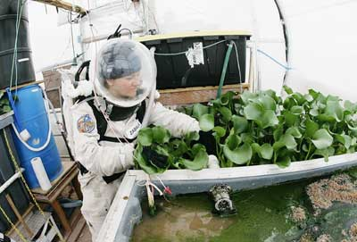
(How)
Luckily, the ISS has a whole team of astronauts (green thumb not required) from around the world specializing in a variety of scientific and engineering fields. Astronauts conduct experiments and improve our knowledge of cultivating plants in space, as well as many other critical arenas of science. Earth-bound researchers and scientists analyze the results and conduct their own experiments, thinking up new theories and possible solutions to test (How).
It is quite possible, that with NASA researching food production some of their discoveries and innovations will lead to better farming and health on Earth. As a result, the difference of food needs between the Moon and Mars missions can one day benefit all mankind for just a half a penny.

Works Cited
Cooper-White, Macrina. "Mars Soil Has Lots Of Water For Explorers, NASA's Curiosity Rover Finds." The Huffington Post. TheHuffingtonPost.com, 26 Sept. 2013. Web. 09 Oct. 2013.
"How Space Farming Works." HowStuffWorks. N.p., n.d. Web. 13 Oct. 2013.
McKee, Maggie. "How Close The Apollo Missions Came To Finding Water." New Scientist 205.2751 (2010): 12. Academic Search Complete. Web. 9 Oct. 2013.
"NASA's 17 Apollo Moon Missions in Pictures." Space.com. N.p., n.d. Web. 13 Oct. 2013.
"Space Chronicles | Moves | Fashion & Lifestyle… Online." Moves Fashion Lifestyle Online. N.p., n.d. Web. 13 Oct. 2013.
Tyson, Neil deGrasse. "The Case For Space." Foreign Affairs 91.2 (2012): 22-33. Academic Search Complete. Web. 13 Oct. 2013.
Tyson, Neil deGrasse. "Why Go to Mars." The American Museum of Natural History: Science Bulletins. Web. 13 Oct. 2013.
Witze, Alexandra. "Space Eats." Science News 180.11 (2011): 20-21. Academic Search Complete. Web. 13 Oct. 2013.

